GOVERNMENT OF ARUNACHAL PRADESH
OFFICE OF THE EXECUTIVE ENGINEERING::PUBLIC HEALTH ENGINEERING & WATER SUPPLY DIVISION, DAPORIJO.

::ORDER::

In continuation to the Notice Inviting Tender (NIT) published in Departmental website “PHEDARUNACHAL.ORG” vide NIT No. DPHE/PB-29/2018-19/, dated 16th August’ 2022 is hereby temporarily postpone on account of unavoidable circumstances and exigencies until further order.

The inconvenience is highly regretted.

Sd/-
Executive Engineer
PHE&WS Division
Daporijo
No.DPHE/PB-61/2022-23/ Dated Daporijo, the 17th Aug’2022
Copy to:-
1) The Mission Director, SJJM, PHE & WS Department, Itanagar for kind information please.
2) The Chief Engineer (WZ), PHE & WS Department, Itanagar for kind information please.
3) The Deputy Commissioner, Upper Subansiri District, Daporijo for kind information please.
4) The Superintending Engineer, PHE & WS Circle, Yachuli for kind information please.
5) Office Copy.

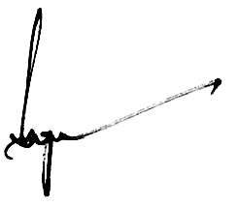
Executive Engineer
PHE&WS Division
Daporijo

